ARCHITECTURE PLAN
Aetos One OS and Hub
Fleet Architecture — Multi-Site Notification and Management Hub
Version | 2.0 — fleet scale
Supersedes | Aetos One Notification Hub Architecture v1 (two-instance scope)
Status | Design only — not built
Scale | All Aetos One OS sites and locations, mixed residential and industrial
Edge platform | Aetos One OS, controlled end to end. Hardware chosen per site requirement — ARM single-board, Intel NUC, AMD or other x86-64.
Control plane | Self-hosted Linux — Mosquitto, n8n, site registry, alert engine
Reasoning | Claude via a single Fleet MCP connector
Date | 19 July 2026
Prepared by | Aetos Techlabs LLP

Read this first
Tier 0 — local critical delivery inside Aetos One OS — has no dependency on the transport, control plane or reasoning tiers. Every other tier can fail without a site losing its safety alerting. That property is the point of the design and should not be traded away for convenience at any later stage.
1. Scope and goals
This document supersedes the two-instance design. The requirement is a fleet spanning all Aetos One sites and locations, residential and industrial, unified under one notification and management hub, with Claude available for diagnosis and authoring rather than for monitoring.
Goals
G1 Three-tier notification — info, warning, critical — from every site, routed by audience.
G2 Critical alerts delivered with zero dependency on the control plane, the internet, or an LLM.
G3 Fleet-wide visibility: which sites are alive, healthy and running a current package.
G4 Author once, deploy to N sites. No per-site hand authoring as routine work.
G5 Per-tenant isolation. No cross-tenant data or control leakage.
G6 One Claude connector for fleet work, not one connector per site.
Non-goals
• An LLM anywhere in the alert delivery path.
• Claude as a continuous monitor — no resident process exists.
• Per-site automation authoring as routine work.
2. Design principles
1. Filter at the edge
Aetos One OS is the lever. Each site decides locally what is worth publishing. Centralising raw state changes from every site to one place is the failure mode that kills fleet architectures.
2. Critical never leaves the site to be delivered
Local notification fires first, always. Publishing to the hub is additive, not the delivery mechanism.
3. Severity is a property of the event; audience is a property of the policy
The edge sets severity. The registry decides who hears it. This is what lets one OS build serve both residential and industrial sites.
4. Aetos One OS, differentiated by enrollment
The same Aetos One OS runs at every site regardless of hardware. No site-specific configuration is baked in — identity and credentials arrive at provisioning.
5. The control plane never gets raw service calls
Only named, allow-listed scripts on the edge may be invoked remotely.
6. One namespace for Claude
A single aggregating MCP server that takes the site as an explicit parameter.
7. Native-first inside Aetos One OS
UI helpers, blueprints and official add-ons. YAML only where no native path exists.
3. Tier model
Read the failure column downward. Every tier's loss is survivable because Tier 0 is independent of all of them.
Tier | Component | Failure impact
T0 — Local safety | Site automation to local notify service | Site loses alerting. Nothing else affected.
T1 — Edge package | Filter, severity tagging, MQTT publish, buffer, heartbeat | Site goes dark to the fleet. T0 unaffected.
T2 — Transport | Mosquitto with per-tenant ACLs | Fleet-wide reporting stops. T0 unaffected at every site.
T3 — Aetos One Hub | Registry, n8n in queue mode, alert engine, fleet operations | No routing, escalation or digests. T0 unaffected.
T4 — Reasoning | Claude via the aggregating MCP server | No analysis or authoring. Nothing operational is affected.

4. Full topology
Colour carries meaning. Red is the Tier 0 safety path that must survive every tier below it. Amber is throttling and escalation. Blue is the Claude-facing interface. Green is the allow-listed remote surface. Dashed outlines are deferred or disabled by default.
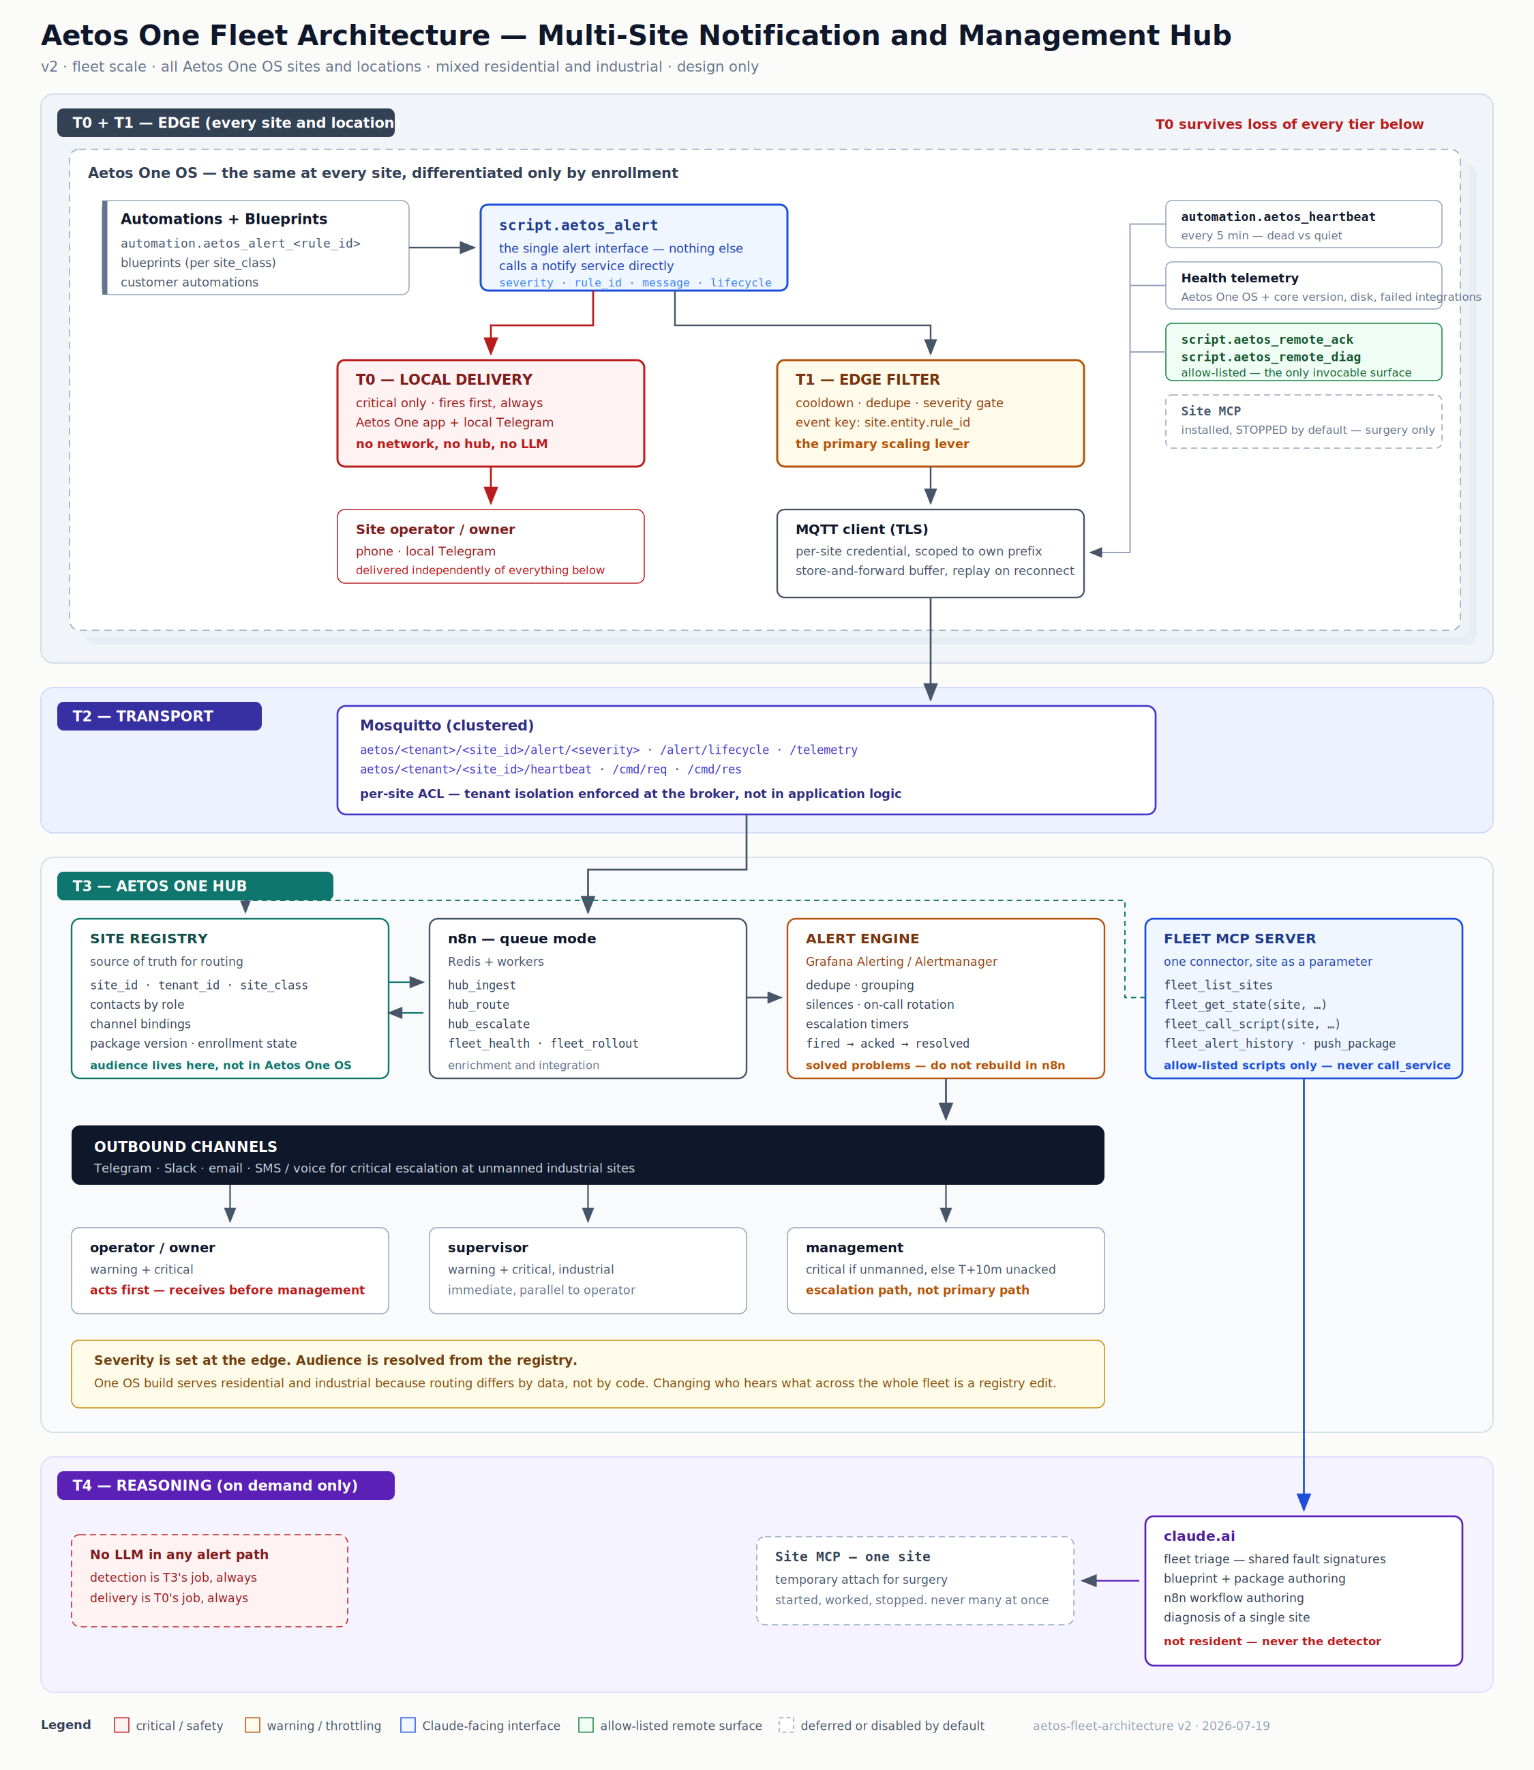
Figure 1 — Aetos One fleet topology, all four tiers.
5. Severity and audience
Two independent axes. The edge sets severity; the registry resolves audience. Fusing them is the most common mistake in this design, and it makes a single OS build unable to serve both site classes.
Severity — set at the edge, identical semantics fleet-wide
Severity | Meaning | Local delivery (T0) | Published
info | Something happened worth recording | No | Yes, batched
warning | Degradation; needs attention this shift or day | No | Yes
critical | Immediate action required — safety, loss or outage | Yes | Yes (additive)

Telemetry is not a severity
Heartbeats, package versions and health data travel on a separate stream and never enter a notification channel. Mixing them is how the information channel becomes unreadable and people stop looking at it.
Audience roles — abstract, mapped per site in the registry
owner · operator · supervisor · management · fleet_ops

Residential sites typically map the owner to all of operator, supervisor and management. That mapping lives in the registry, not in Aetos One OS.
Routing matrix
Severity | Residential (res-*) | Industrial (ind-*)
info | Site channel, daily digest | Site channel, daily digest
warning | owner | operator + supervisor
critical | owner immediately; fleet_ops if unacknowledged at T+15 min | operator + supervisor immediately; management immediately if unmanned, otherwise at T+10 min unacknowledged

Escalation direction — correct this before building
Critical alerts go first to whoever can act, not to whoever is most senior. Management sits on the escalation path, not the primary path. Routing critical alerts to management alone means the person who can close the valve is not told.
6. Alert lifecycle
Fire-and-forget produces channels full of alerts that have already self-cleared. Across a fleet that produces alert fatigue within weeks. Every alert carries a lifecycle state.
fired ─────► acked ─────► resolved
│ │ ▲
│ └──────────────┘
└── unacknowledged after T ──► escalate to next role

State | Emitted by | Effect
fired | Edge, when the rule condition becomes true | Route per matrix; start the escalation timer
acked | Recipient, via mobile app action, Telegram callback or script.aetos_remote_ack | Stop the escalation timer; annotate the alert
resolved | Edge, when the rule condition clears | Close the alert; post the resolution to the same threads

Dedupe key: site_id.entity_id.rule_id. The same key within its cooldown suppresses and increments a counter rather than re-firing. Cooldowns are 60 seconds for critical, 300 for warning, 900 for info.
7. Naming conventions
Product names
Name | Refers to
Aetos One | The product line as a whole
Aetos One OS | The edge operating system — every site runs this, on whatever hardware that site requires
Aetos One Hub | The control plane — registry, ingest, routing, escalation, fleet operations
Aetos Techlabs LLP | The legal entity

Use the full form on first mention in any section; “the Hub” is acceptable thereafter. Lowercase code identifiers — the aetos_ entity prefix and the aetos/ MQTT topic root — are unchanged.
Identifiers
Item | Convention | Example
Tenant | lowercase slug | sumeru
Site class | res | ind | ind
Site ID | <class>-<code>-<nnn> | ind-wpa-001, res-hyd-014
Severity | info | warning | critical | —
Audience role | owner | operator | supervisor | management | fleet_ops | —
Lifecycle | fired | acked | resolved | —
Rule ID | <domain>_<condition> | tank_level_low, pump_dry_run
Event key | <site_id>.<entity_id>.<rule_id> | ind-wpa-001.sensor.raw_tank.tank_level_low
Package version | semver | aetos-edge 1.4.0

Site class is embedded in the site ID so that routing, broker ACLs, dashboards and rollout targeting can all shard on a prefix without a registry lookup.
MQTT topics
aetos/<tenant>/<site_id>/alert/<severity> edge → hub alert events
aetos/<tenant>/<site_id>/alert/lifecycle edge → hub fired / acked / resolved
aetos/<tenant>/<site_id>/telemetry edge → hub health, versions, disk
aetos/<tenant>/<site_id>/heartbeat edge → hub every 5 minutes
aetos/<tenant>/<site_id>/cmd/req hub → edge allow-listed commands
aetos/<tenant>/<site_id>/cmd/res edge → hub command results

ACL per site
Publish to aetos/<tenant>/<site_id>/# and subscribe only to that site's cmd/req. One recovered SD card cannot observe or control another site.
Aetos One OS entities — all aetos_ prefixed
input_text.aetos_site_id script.aetos_alert
input_text.aetos_tenant_id script.aetos_remote_ack
input_select.aetos_site_class script.aetos_remote_diag
binary_sensor.aetos_link_online automation.aetos_heartbeat
sensor.aetos_package_version automation.aetos_alert_<rule_id>

The prefix makes package-owned entities unmistakable, greppable, and resilient to customer tinkering.
Blueprints and workflows
blueprints/aetos/industrial/<rule_id>.yaml
blueprints/aetos/residential/<rule_id>.yaml

n8n: hub_ingest · hub_route · hub_escalate · fleet_health · fleet_rollout

8. The single alert interface
Every automation on every site calls script.aetos_alert. Nothing else calls a notification service directly. This is the abstraction that makes fleet-wide channel changes a registry edit rather than a site-by-site visits.
fields:
severity: info | warning | critical # required
rule_id: tank_level_low # required
message: "Raw tank below 15%" # required
entity_id: sensor.raw_tank_level # optional
area: Filtration # optional
lifecycle: fired | acked | resolved # default: fired

Behaviour
1. If severity is critical and lifecycle is fired, deliver locally immediately. This is Tier 0.
2. Apply the edge filter: cooldown and dedupe on the event key.
3. Publish to the alert and lifecycle topics for this site.
4. If the broker is unreachable, buffer, retry with backoff, and replay on reconnect.
9. Aetos One OS Edge Package
Ships inside Aetos One OS. The same package runs at every site, on any supported hardware. No site-specific configuration is baked in.
Component | Purpose
Site identity helpers | site_id, tenant_id, site_class — populated at enrollment
script.aetos_alert | The single alert interface
Local critical path | Aetos One mobile app and local Telegram, with no network round-trip
Edge filter | Cooldown, dedupe and severity gate — the primary scaling lever
MQTT client | TLS, per-site credential, namespaced topics
Store-and-forward | Buffers on broker loss, replays on reconnect
Heartbeat | Publishes every five minutes
Health telemetry | Aetos One OS and core version, package version, disk, failed integrations, unavailable-entity count
Allow-listed remote actions | script.aetos_remote_ack and script.aetos_remote_diag — the only invocable surface
Blueprints | Per site-class automation templates
Site MCP | Installed but stopped by default. Started only for surgery on a single site.

Package updates must be independent of Aetos One OS updates
You cannot reflash every device in the field to fix an alert rule. Ship the package as a self-hosted Aetos One OS package repository or a custom add-on with its own update channel. Aetos One OS ships version 1; the fleet moves to version 2 over the air, targeted by tenant or site-class prefix, with pinning and rollback as first-class operations. Sequence package rollout against core updates — never concurrently.
10. Enrollment
Designed now, because the alternative is connecting to every device by hand.
Step | Actor | Action
1 | Device | First boot — Aetos One OS onboarding displays a claim code
2 | Operator | Enters the claim code in the Aetos One Hub portal
3 | Portal | Creates the registry row: site_id, tenant_id, site_class
4 | Portal | Issues a per-site MQTT credential scoped to that site's topic prefix
5 | Device | Fetches identity and credential, populates the aetos_ helpers
6 | Device | Publishes its first heartbeat
7 | Registry | Marks the site enrolled; routing becomes active

Per-site credentials are non-negotiable
A shared broker credential shipped inside Aetos One OS means one recovered SD card compromises the entire fleet's telemetry. Credential rotation must also be possible without a site visit — design that into enrollment from day one.
11. Claude access model
One connector for fleet work, not one per site.
Purpose | Connector | Permanence
Fleet triage, rollout, history, allow-listed actions | Fleet MCP server | Permanent
Hub operations and workflow authoring | n8n MCP | Permanent
Deep surgery on one problem site | That site's Site MCP | Temporary — start, work, stop

Why not one connector per site
• Every Site MCP instance exposes identically named tools. With many attached, disambiguation errors are silent and site-fatal — acting on ind-wpa-047 when you meant ind-wpa-074.
• Tool descriptions are large. Every additional namespace consumes context budget before any work begins.
• One endpoint and token per site to rotate, expire and audit.
The Fleet MCP server takes site_id as an explicit parameter, which makes site selection auditable rather than implicit, and lets policy be enforced centrally — for example, requiring that any write targeting an industrial site names an allow-listed script.
What Claude does at this scale
• Authors blueprints and packages once, versioned and shipped — a handful of artifacts covering every site and location.
• Fleet triage: which sites share a fault signature this week.
• Authors and refactors control-plane workflows in n8n.
• Diagnoses a single problem site through a temporary Site MCP attachment.
What Claude does not do
• Continuous monitoring. There is no resident process. Detection belongs to the control plane, always.
• Per-site automation authoring as routine work.
• Anything at all in the Tier 0 delivery path.
12. Security model
Control | Design
Broker credentials | Per site, scoped to that site's topic prefix. Never shared.
Transport | TLS to the broker; mutual TLS preferred where the hardware supports credential rotation.
Tenant isolation | Topic namespace plus broker ACL. Enforced at the broker, not in application logic.
Remote control | Allow-listed named scripts only. The control plane never gets a raw service call.
Industrial writes | Any command targeting an industrial site requires an allow-listed script name and is logged with actor, site, script and timestamp.
Site MCP exposure | Stopped by default. Started per incident, reachable only through the control plane.
MCP endpoints | Authenticated. Fleet MCP write scope kept separate from read scope.
Registry | Source of truth for contacts and routing. Access-controlled and audited.
Credential rotation | Per-site rotation possible without a site visit.

13. Reliability and failure modes
Failure | Detection | Behaviour
Site loses internet | Heartbeat gap over 15 minutes | T0 alerts still delivered locally; edge buffers for replay; fleet_ops notified of site down
Broker down | Edge MQTT reconnect fails | All sites buffer; T0 unaffected; hub watchdog alerts
n8n down | Ingest lag and worker health | Alert engine continues if fed directly; enrichment and digests stop
Alert engine down | Self-monitoring | n8n falls back to direct channel send for critical alerts
Site dead vs site quiet | Heartbeat is the only discriminator | Never remove heartbeats to reduce traffic
Flapping sensor | Edge cooldown and dedupe counter | Suppressed at source; never reaches the hub
LLM or API failure | Digest workflow error | Digests skipped. No alert path affected.

The characteristic failure of hub architectures
Silence being indistinguishable from health. Heartbeats from the edge, plus a hub-reachability sensor on the edge, cover both directions.
14. Worked example — critical alert at an industrial site
Time | Event
T+0.0s | ind-wpa-001: raw tank level crosses below 15%
T+0.1s | automation.aetos_alert_tank_level_low fires, calling script.aetos_alert with severity critical, lifecycle fired
T+0.2s | Tier 0: Aetos One mobile app critical notification and local Telegram reach the OPERATOR. Delivered. Nothing upstream was required.
T+0.3s | Edge filter: the event key is not in cooldown, so publish
T+0.4s | MQTT: aetos/sumeru/ind-wpa-001/alert/critical
T+0.6s | hub_ingest resolves the registry: site class industrial, contacts resolved
T+0.8s | Alert engine groups, dedupes and starts the T+10 minute escalation timer
T+1.0s | Telegram reaches the SUPERVISOR; the unmanned flag is set, so MANAGEMENT is notified too
T+4m | Operator acknowledges via a mobile app action, which calls script.aetos_remote_ack. Lifecycle becomes acked and the escalation timer is cancelled.
T+22m | Tank refills above threshold. Lifecycle becomes resolved and the resolution is posted to the same threads.

Note the independence
Step T+0.2s completes without any dependency on the eight steps that follow it. If the broker, the control plane and the internet are all unavailable, the operator is still notified.
15. Build phases
Phase | Deliverable | Value if you stop here
P1 | Severity taxonomy, registry schema and naming conventions frozen | Everything downstream has a stable contract
P2 | script.aetos_alert, local T0 delivery and blueprints on two reference sites | Working critical alerting with no hub required
P3 | Edge package v1 — identity, MQTT, filter, buffer, heartbeat — baked into Aetos One OS | Sites report; the fleet becomes observable
P4 | Broker with per-site ACLs; enrollment flow and portal | The fleet can actually be provisioned
P5 | Control plane: registry, n8n in queue mode, ingest, routing and escalation | Routing, escalation and lifecycle
P6 | Alert engine, fleet health dashboard, watchdogs | A hub you can trust
P7 | Fleet MCP server; connect Claude | Fleet triage and authoring
P8 | Package rollout and rollback tooling | Safe fleet-wide change

Sequencing constraint
Phase 2 alone delivers correct critical alerting at every site with no hub, no LLM and no network dependency. Do not begin Phase 7 before Phase 6 — connecting a reasoning layer to an unmonitored hub means silent failures get interpreted rather than detected.
16. Rejected and deferred options
Option | Verdict
n8n as an Aetos One OS add-on | Rejected. Couples hub lifecycle to site restarts; the hub must be up when a site is not.
One Site MCP connector per site | Rejected. Namespace collision produces silent wrong-site actions.
A resident LLM agent as the alert transport | Rejected. One agent is a single point of failure for every site's safety alerts; per-site agents mean one process and an LLM call per alert, everywhere.
n8n as the alert engine at fleet scale | Deferred to a purpose-built engine. Grouping, silences, on-call rotation and escalation are solved problems elsewhere.
Claude as a continuous monitor | Not possible. There is no resident process.
Shared broker credential inside Aetos One OS | Rejected. One recovered SD card compromises the fleet.
A single shared channel for residential and industrial | Rejected. Guarantees alert fatigue on the industrial channel.

17. Open decisions
These block the phases named. Decisions 1 and 2 block everything.
# | Decision | Blocks
D1 | Are the sites yours, or customers'? Multi-tenancy makes isolation and per-tenant routing hard requirements rather than hygiene. | P1
D2 | Does a residential critical alert reach fleet_ops? Saying yes takes on a monitoring obligation for every residential location, and the liability for missing one. | P1
D3 | Broker location — a residential site, the control-plane host, or dedicated infrastructure. Industrial sites must not depend on a residential instance. | P4
D4 | Alert engine choice. On-call rotation and silences are the deciding features. | P6
D5 | Package distribution: self-hosted Aetos One OS package repository or a custom add-on channel. Determines rollback mechanics. | P3
D6 | Acknowledgement mechanism: mobile app actionable notification, Telegram callback, or both. | P5
D7 | Does a multi-instance Site MCP variant already exist, or is the Fleet MCP server a build? Materially changes the estimate. | P7
D8 | Which site the current elegante connector points at. | P2
D9 | SMS or voice provider for critical escalation. Telegram alone is insufficient for unmanned industrial sites. | P6

Appendix A — Component mapping
Internal build reference — remove from customer-facing copies
The body of this document uses Aetos One OS and Hub naming throughout. This appendix maps each Aetos One name to the upstream component it is built on, so that anyone implementing from this document can find the actual artifact. Without it, a build engineer searching for “Site MCP” will find nothing.
Aetos One name | Upstream component | Notes
Aetos One | Rebranded Home Assistant OS | Build 6 golden master; Phase 2 fork queued for banner, os-release and kernel splash
Site MCP | ha-mcp add-on | Shipped installed but stopped. Started only for single-site surgery.
Fleet MCP server | To be built, or a multi-instance ha-mcp variant | See decision D7 — check the upstream project before estimating
Aetos One OS package repository | Self-hosted HACS custom repository, or a custom add-on channel | See decision D5 — determines rollback mechanics
Aetos One mobile app | Home Assistant Companion App | Provides the notify.mobile_app_* services and actionable notifications used for acknowledgement
script.aetos_alert | Native script entity | Created through the UI; no YAML required
Local critical delivery | Native notify integration | notify.mobile_app_* plus the Telegram integration
Edge MQTT client | Native MQTT integration plus the official Mosquitto broker add-on | Broker may be central rather than per site — see decision D3
Site identity helpers | Native helpers — input_text and input_select | Created through Settings, Devices and Services, Helpers
Blueprints | Native automation blueprints | Per site class, shipped inside Aetos One OS
Hub reachability sensor | Template binary sensor | Fed by the hub heartbeat returning to the site

Every component above is either a native feature, an official add-on, or a project already in use. Nothing in this architecture requires a custom integration to be written from scratch except the Fleet MCP server, and that may not be needed either — see decision D7.
End of document

